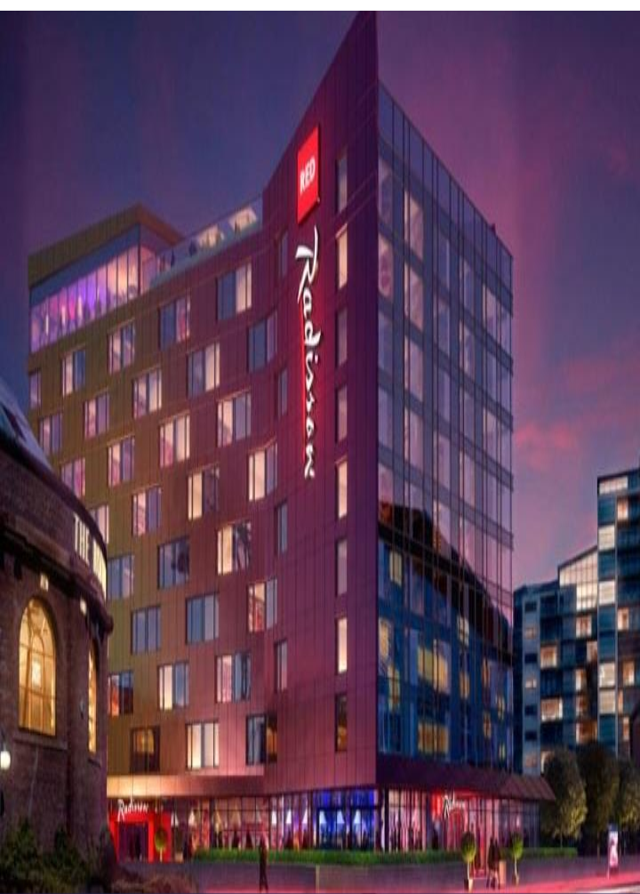

*PROJECT NAME:*



Analyzing the Performance & Efficiency of The Radisson Hotels using Data Visualization Techniques.

***TEAM MEMBERS:***

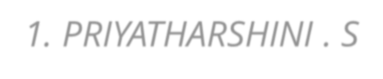

*1. PRIYATHARSHINI . S 2. KAVINILA .T*

*3. KAVITHA .S.K 4. MELSIYA .M*

***INTRODUCTION:***

* The hotel industry is a broad category of businesses that provide lodging services for travellers and tourists. This can include a wide range of establishments, from luxury resorts to budget-friendly motels, as well as extended stay hotels, boutique hotels, and more. Hotels can be found in nearly every corner of the world, and are often a major component of the tourism and travel industry in a given area.

* Radisson owns multiple five-star hotels across India. They have been in the hospitality industry for the past 100 years. Due to strategic moves from other competitors and ineffective decision-making in management, Radisson is losing its market share and revenue in the luxury/business hotels category. As a strategic move, the managing director of Radisson wanted to incorporate Business and Data Intelligence in order to regain their market share and revenue. Our task is to create an analytics dashboard & story to provide them insights to make better business decisions.

***PROBLEM DEFINITION & DESIGN THINKING 2.1 EMPATHY MAP:***

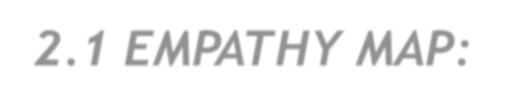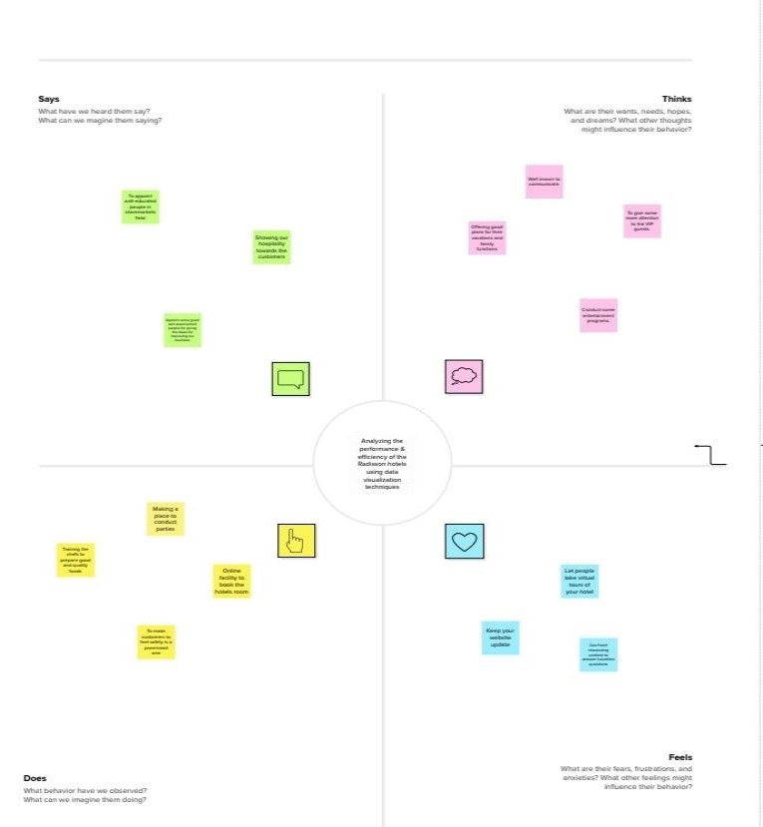

***2.2 IDEATION & BRAINSTORMING MAP:***

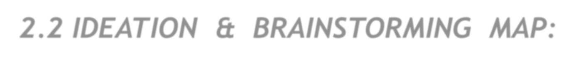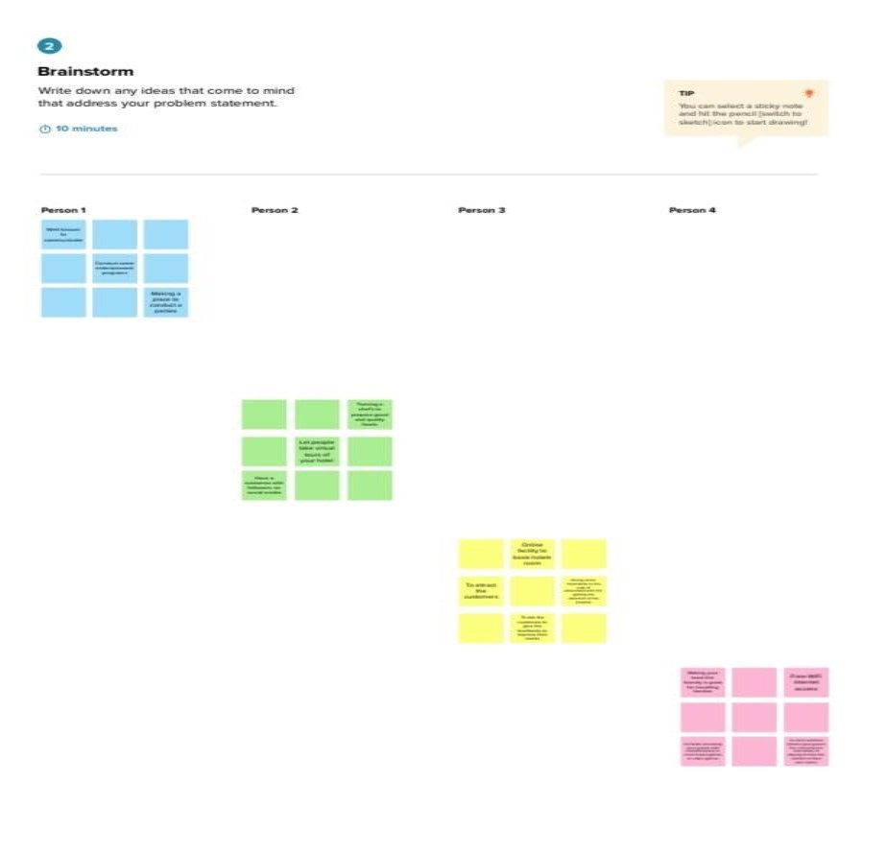

***Screenshot:***

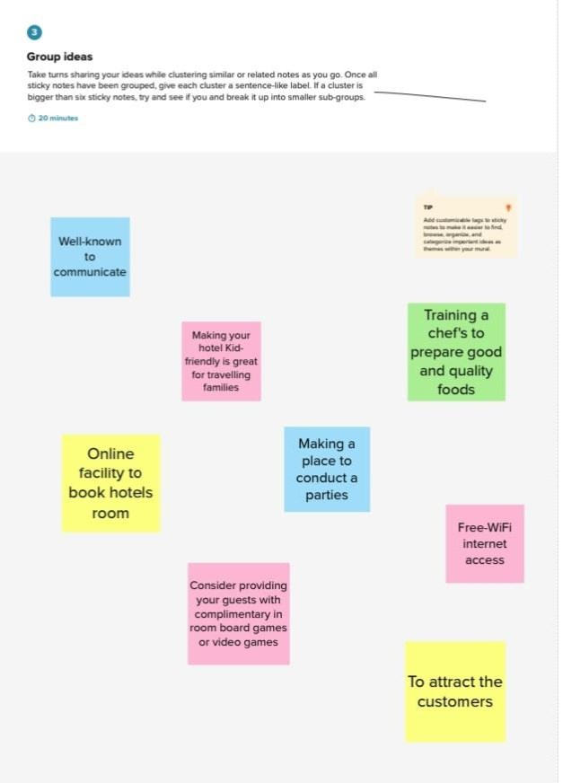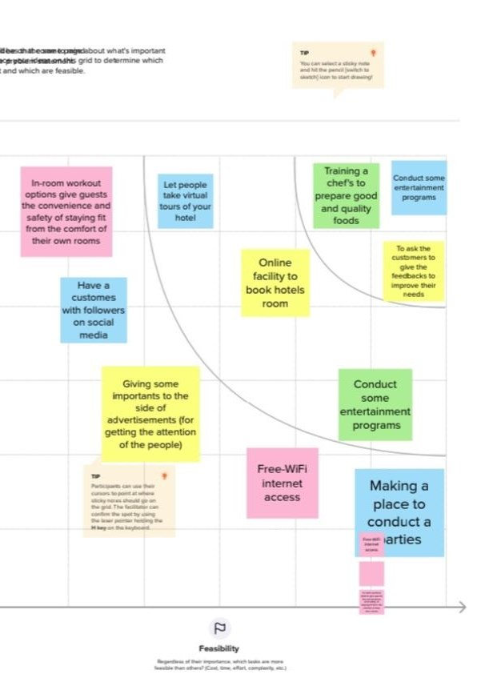

***3. RESULT:***

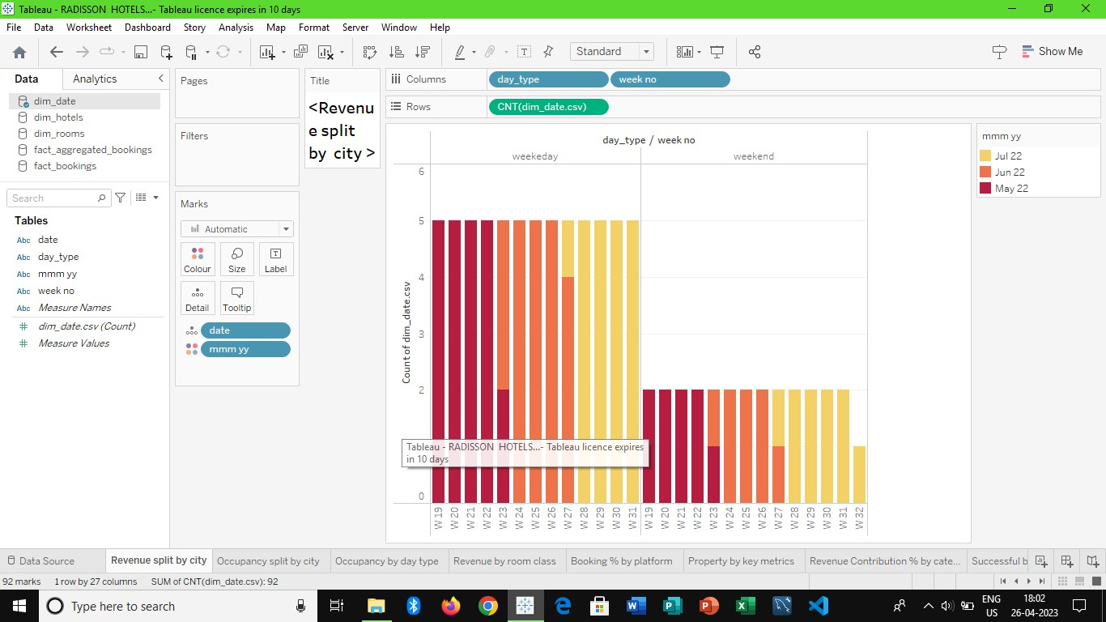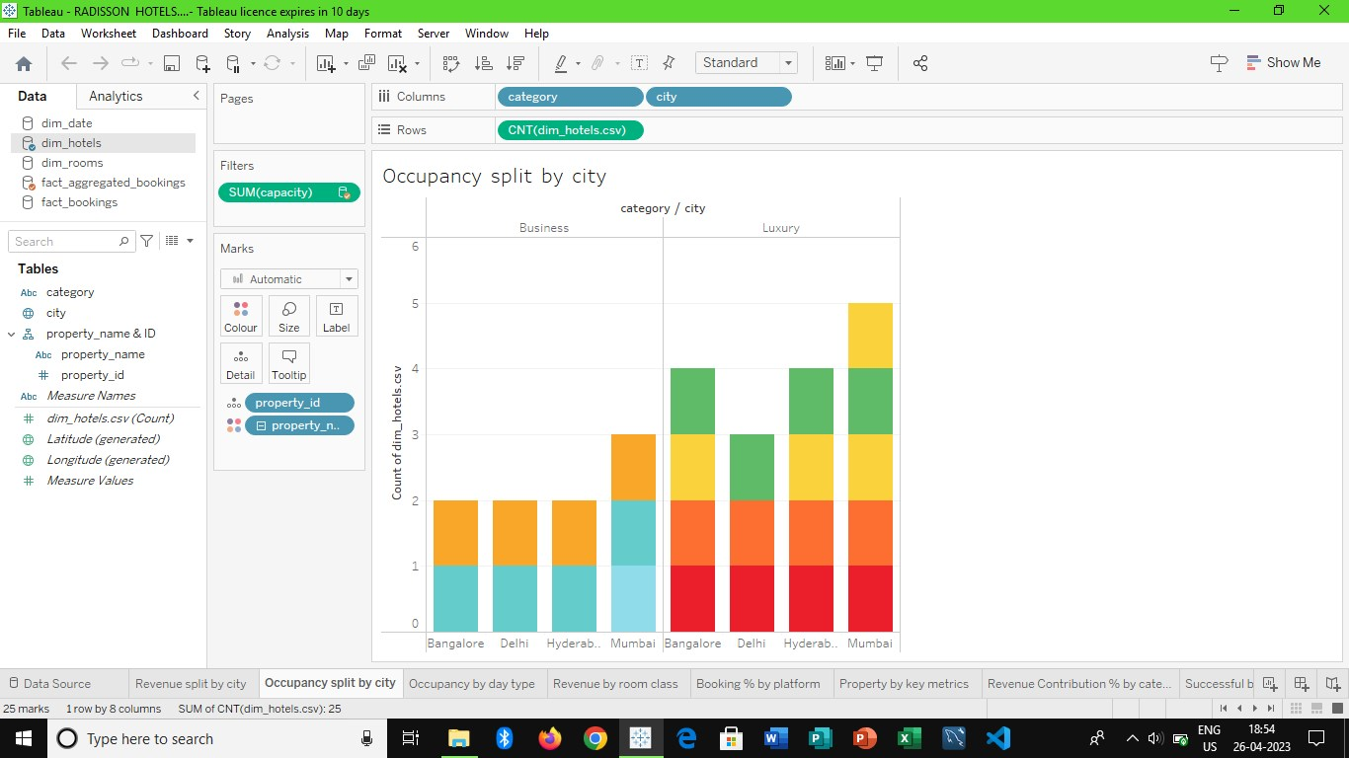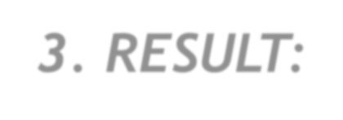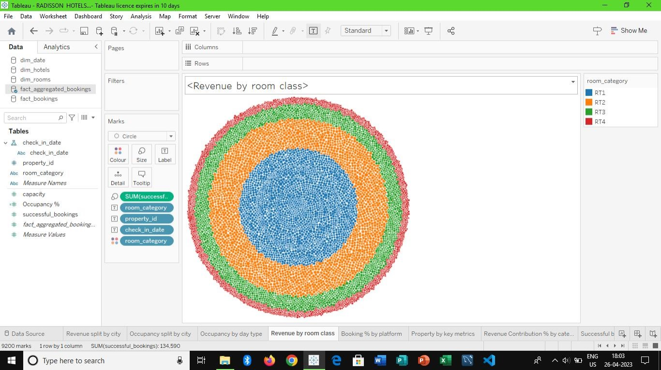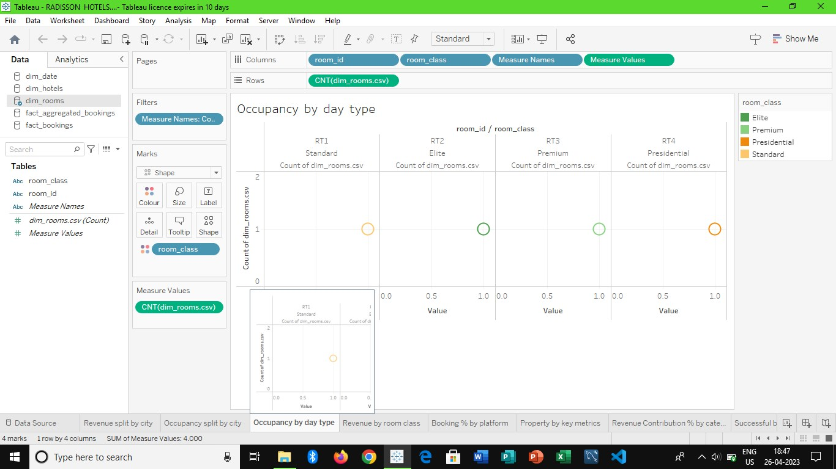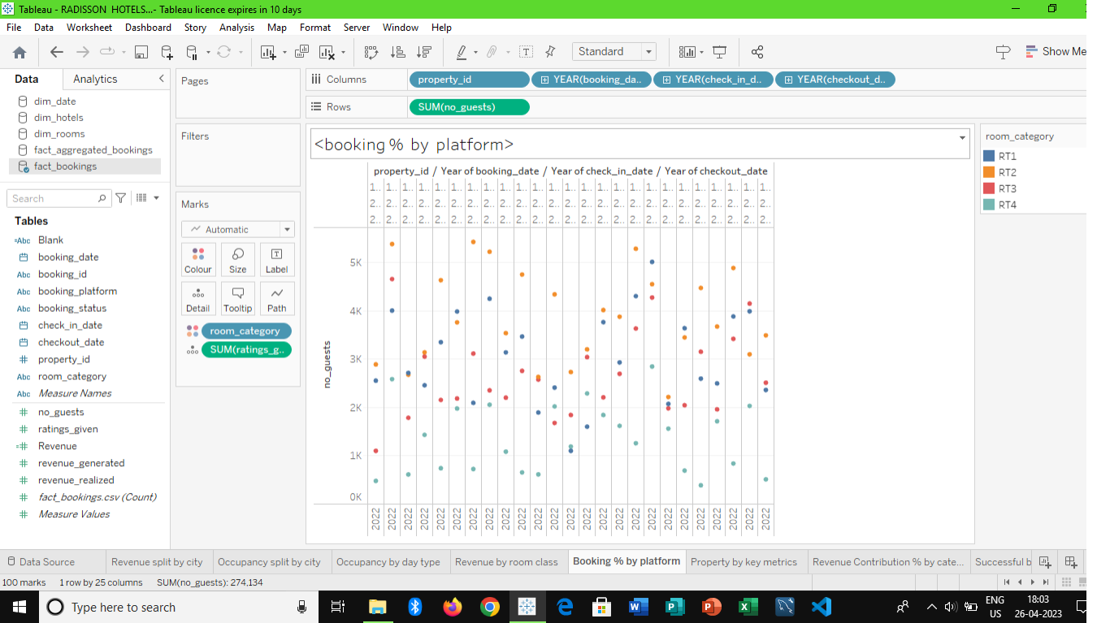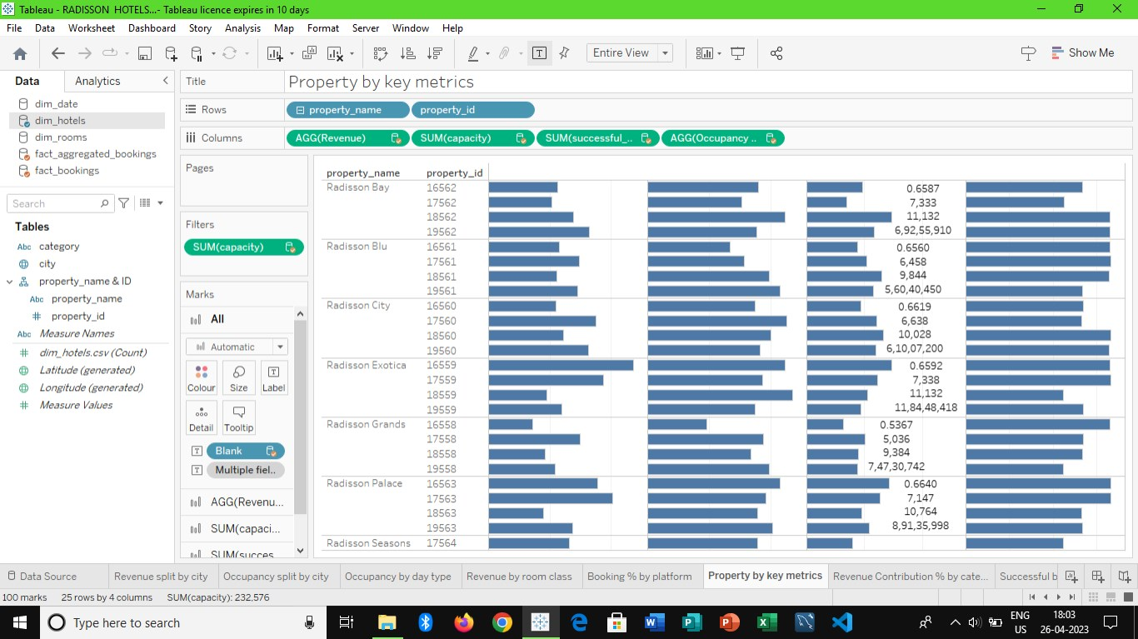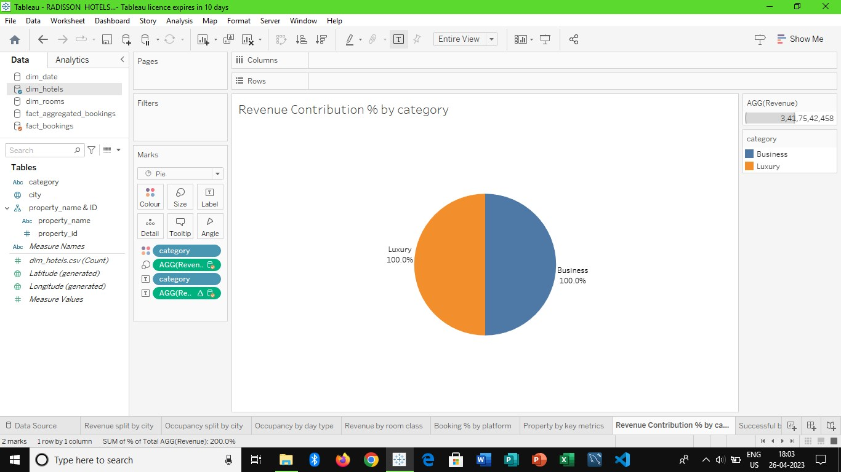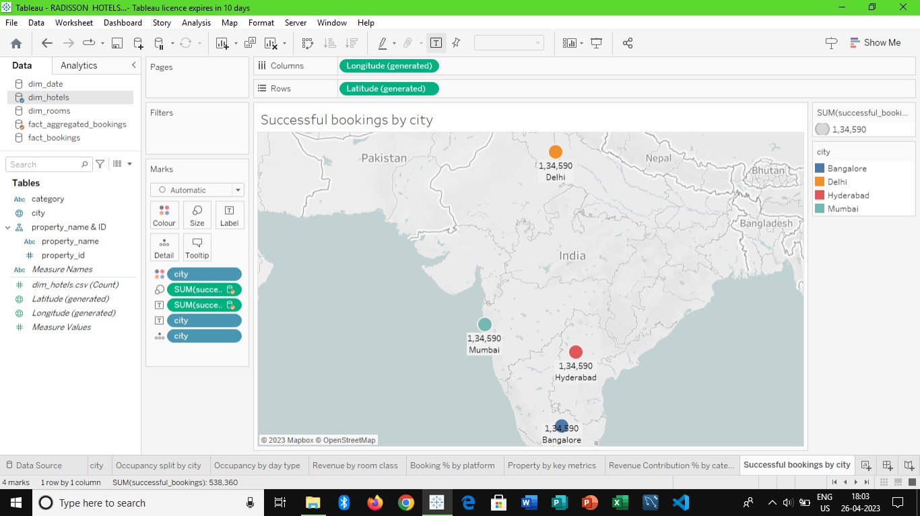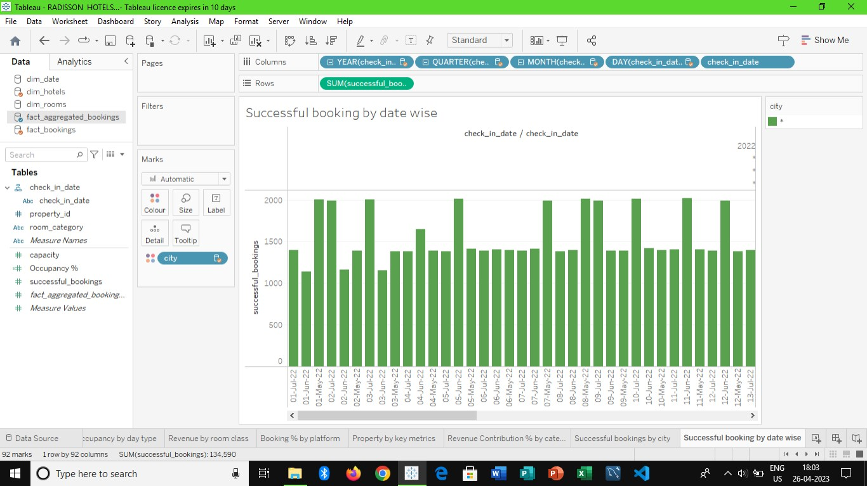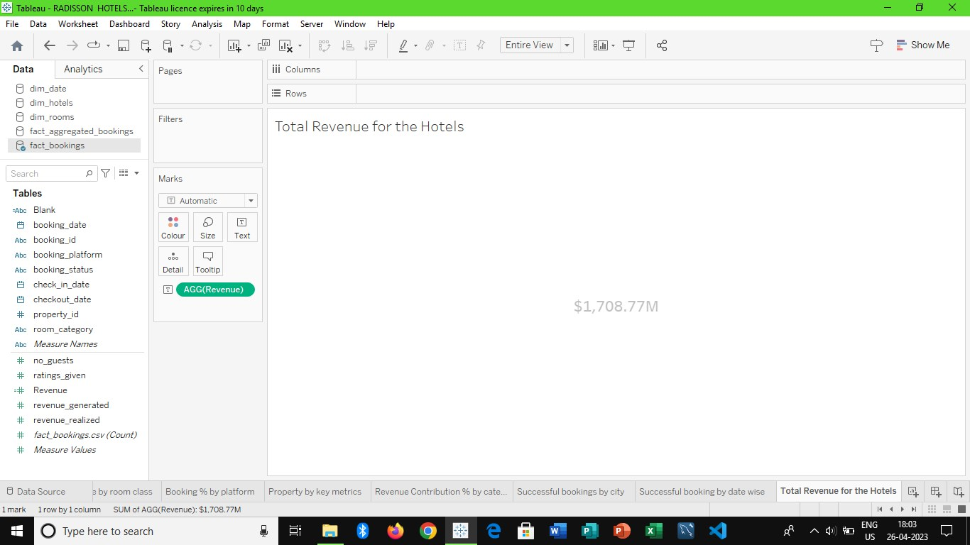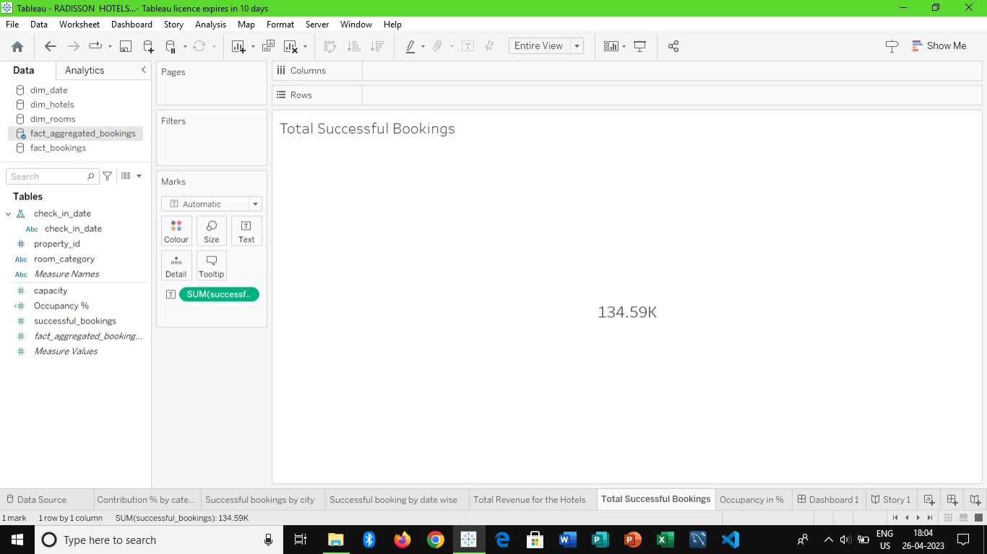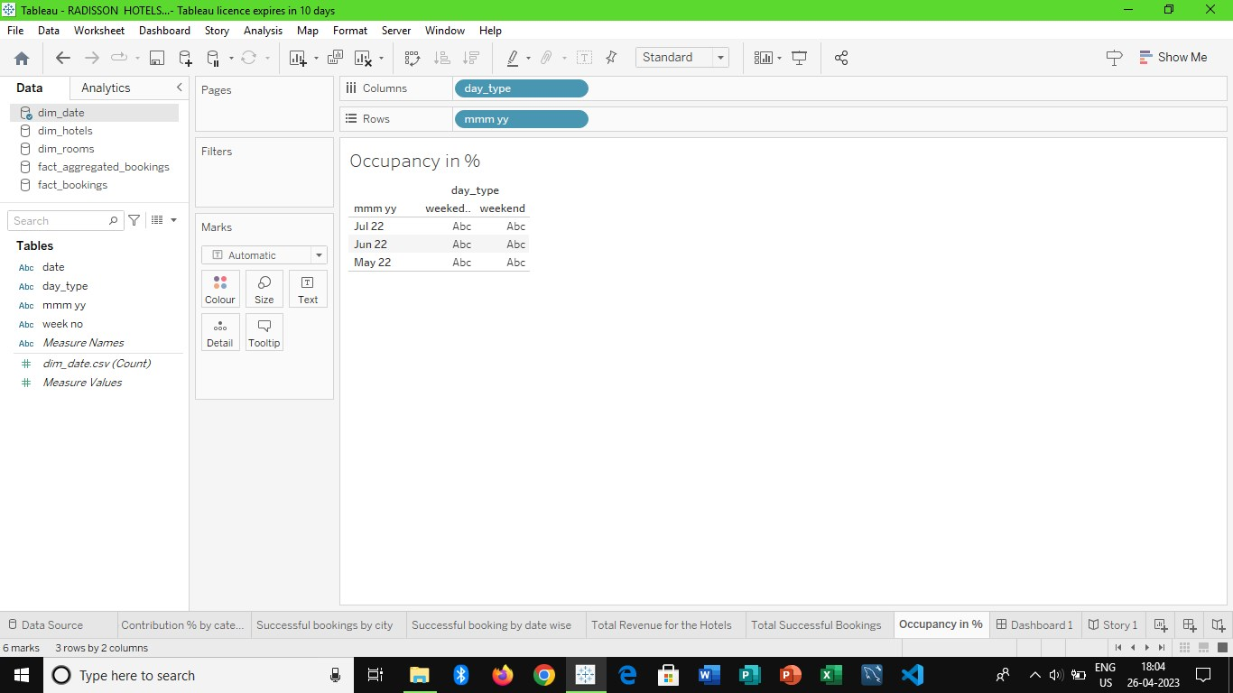

***Dashboard:***

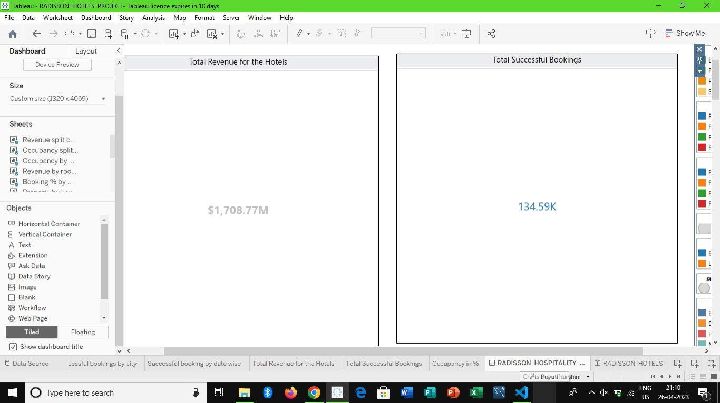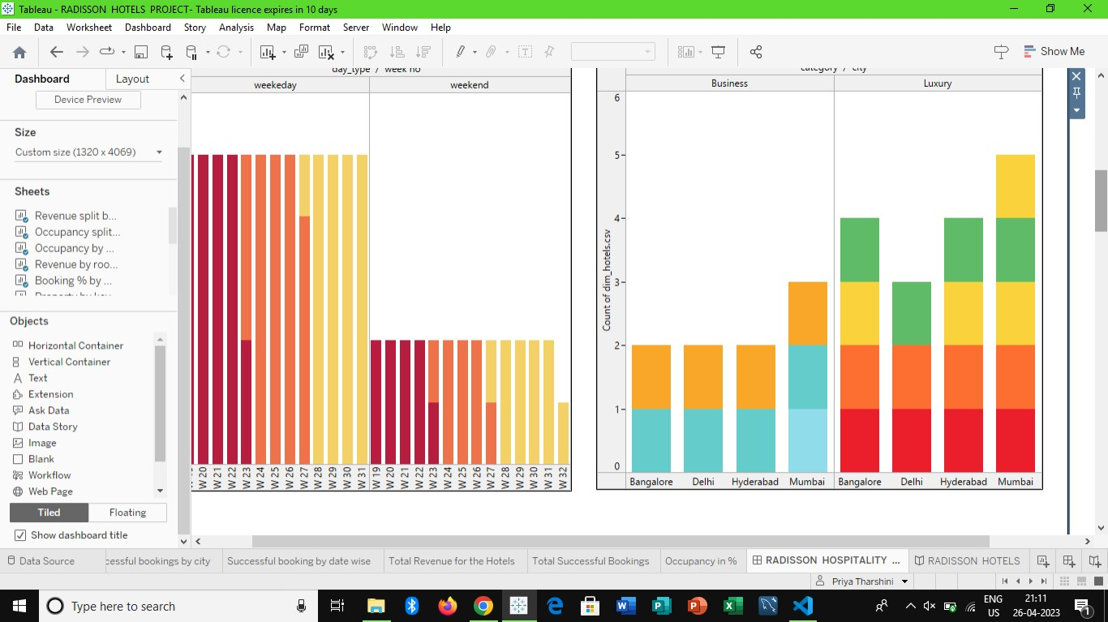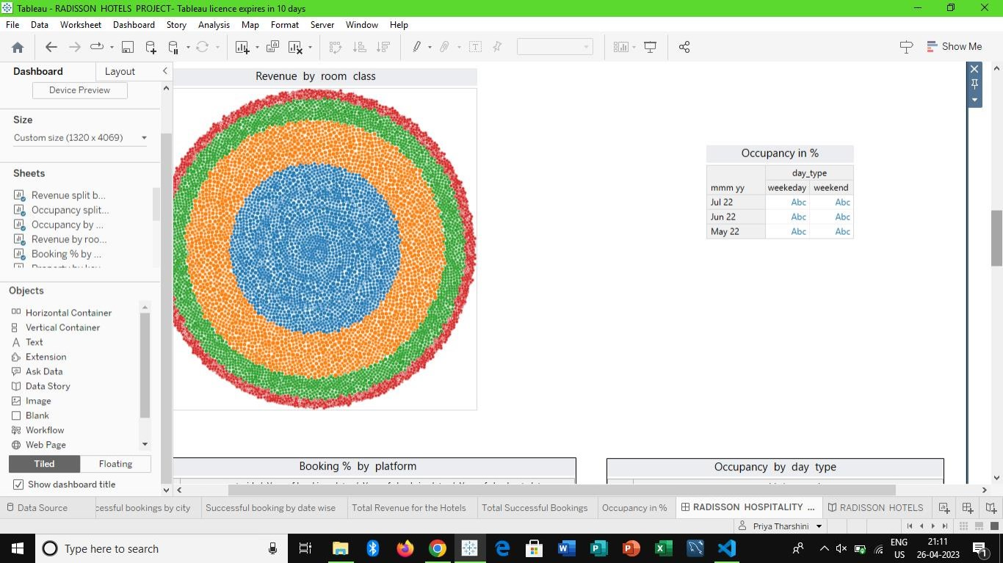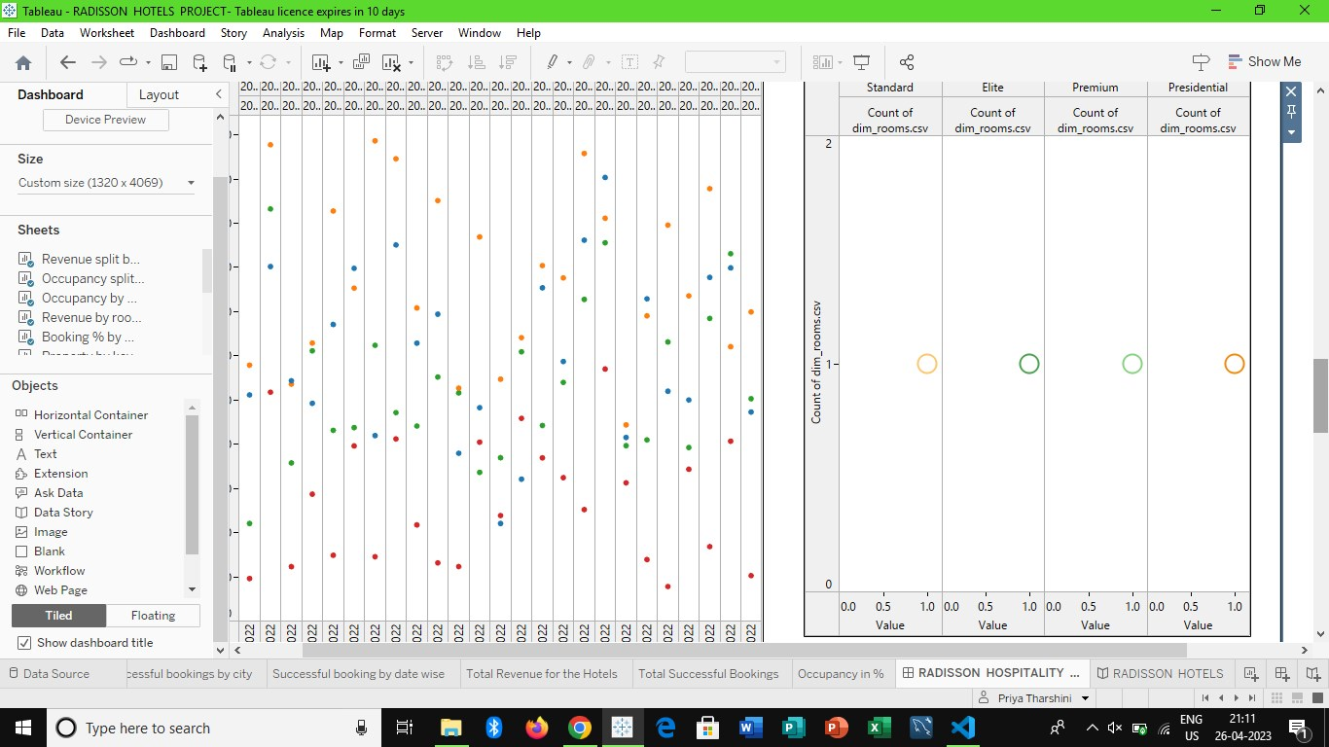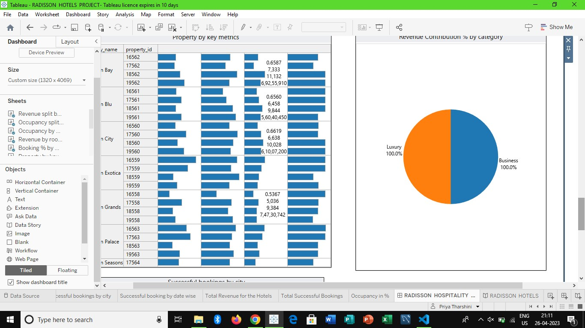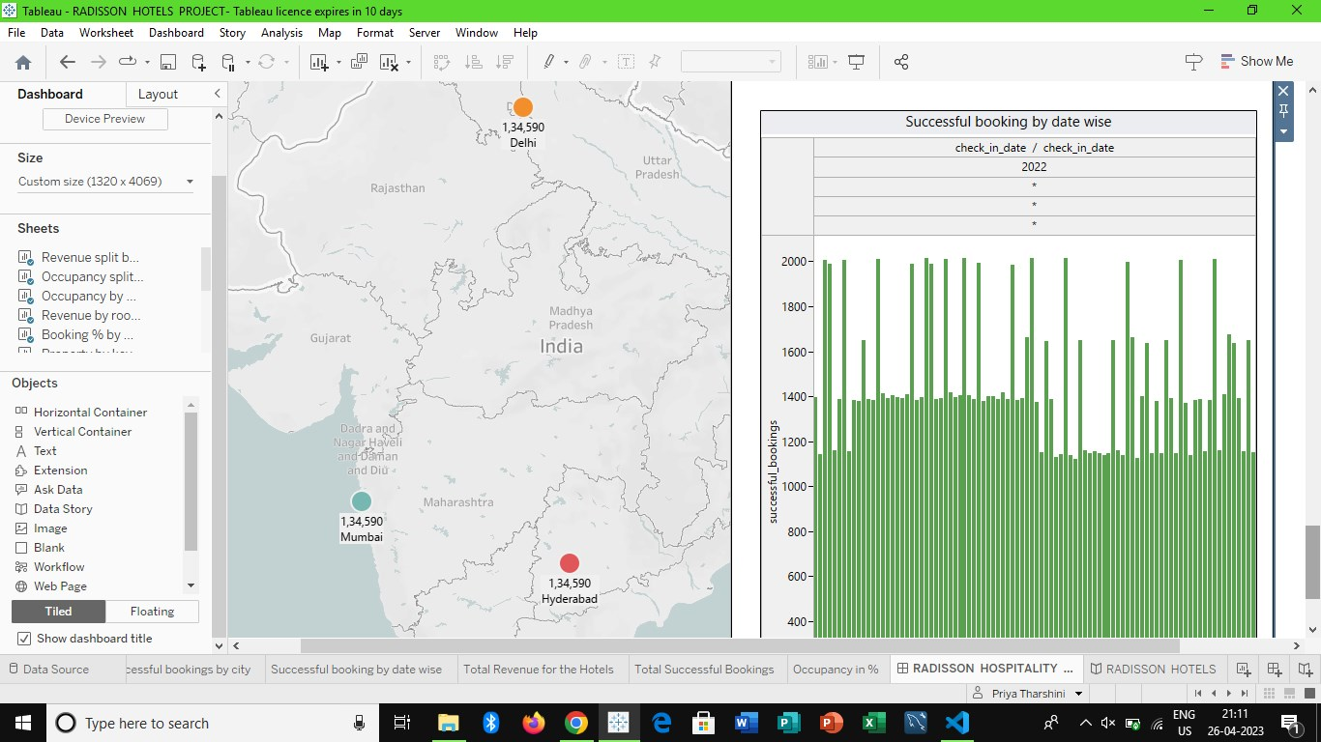

***Story:***

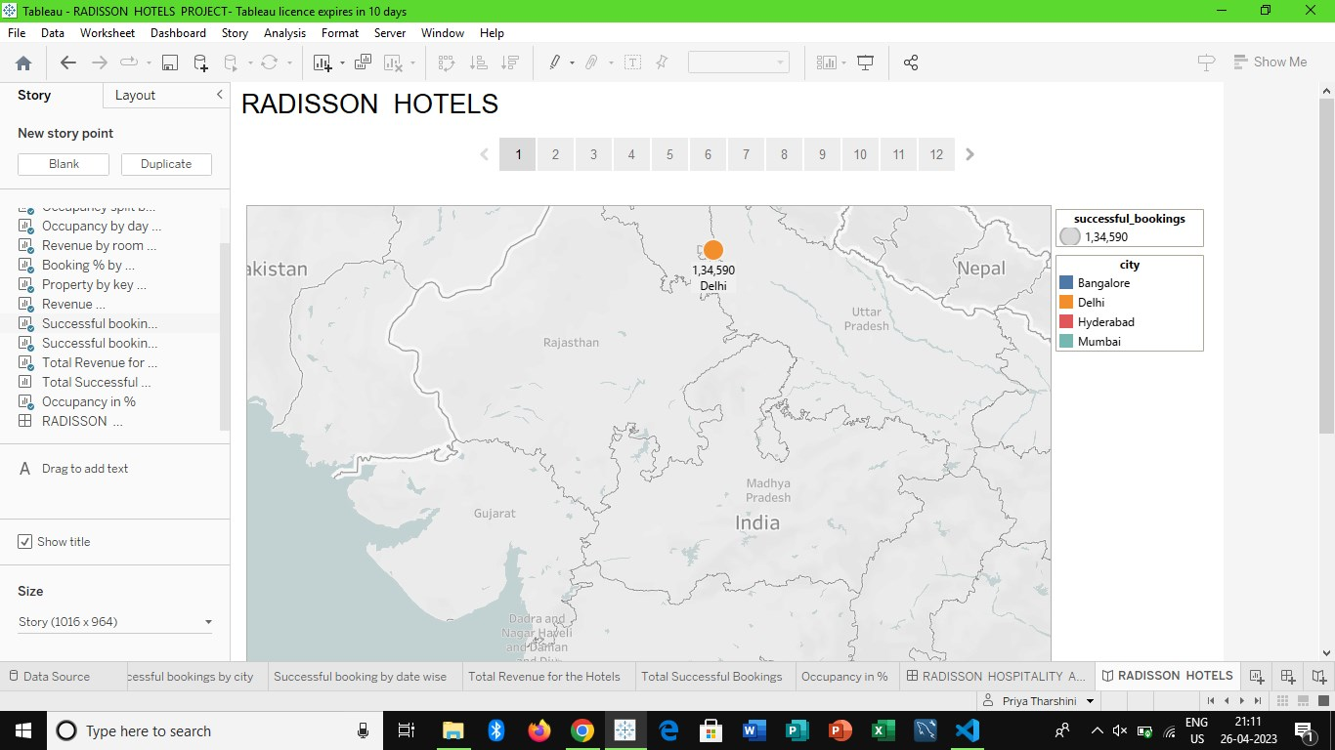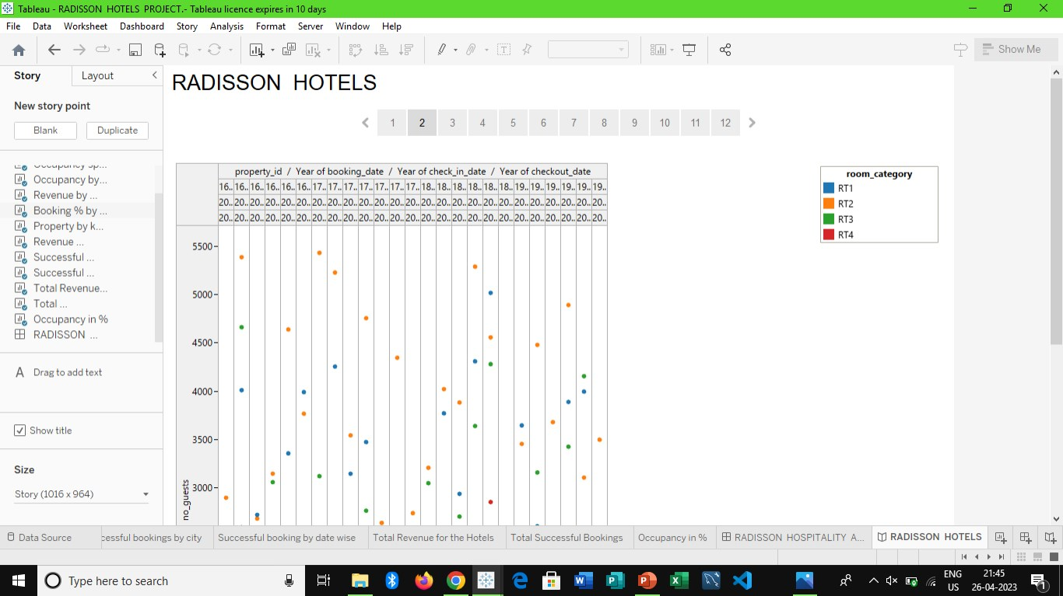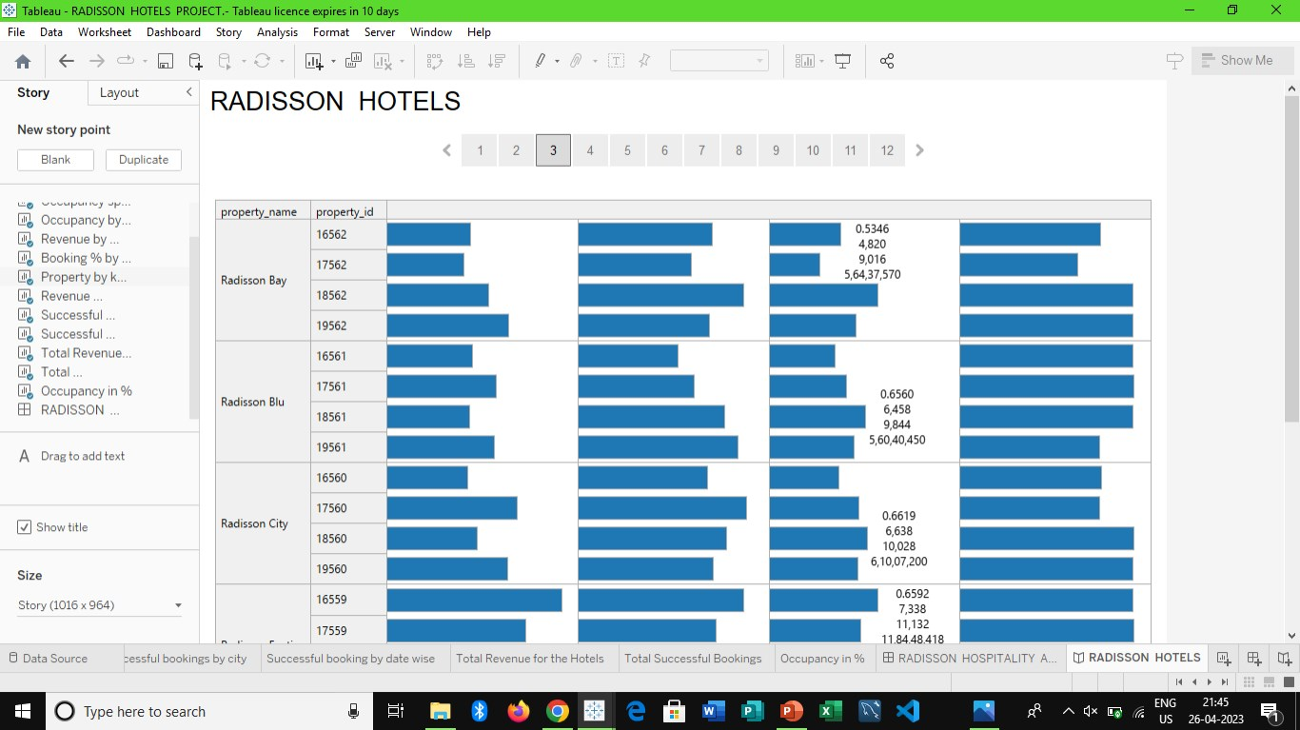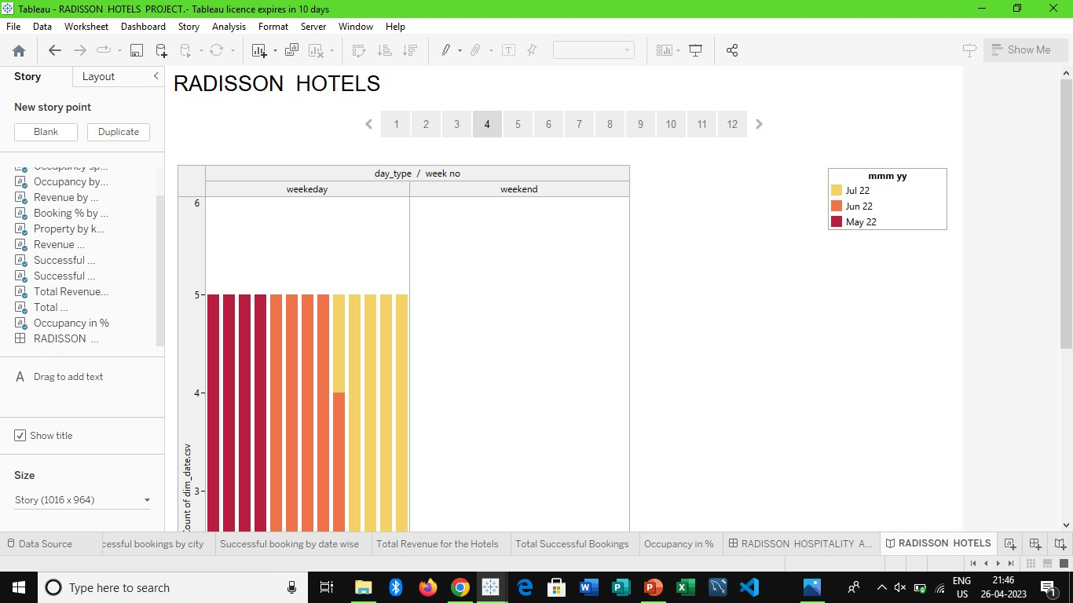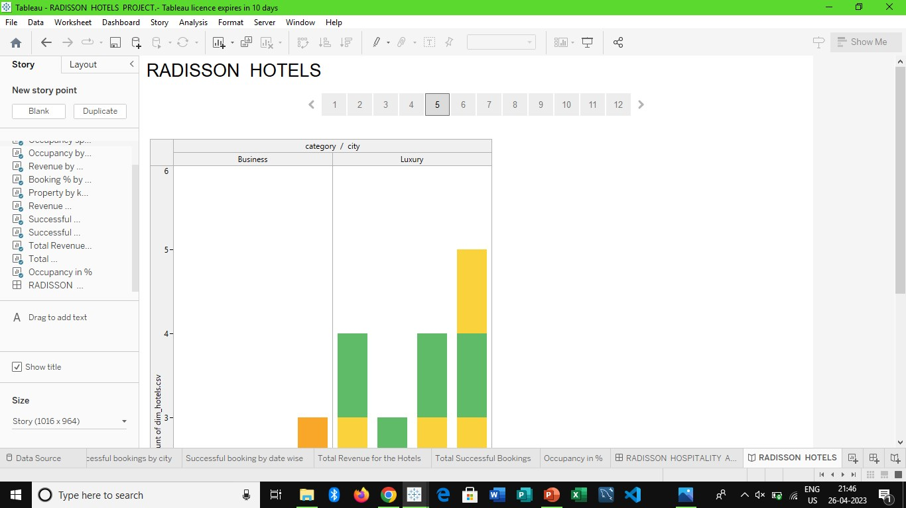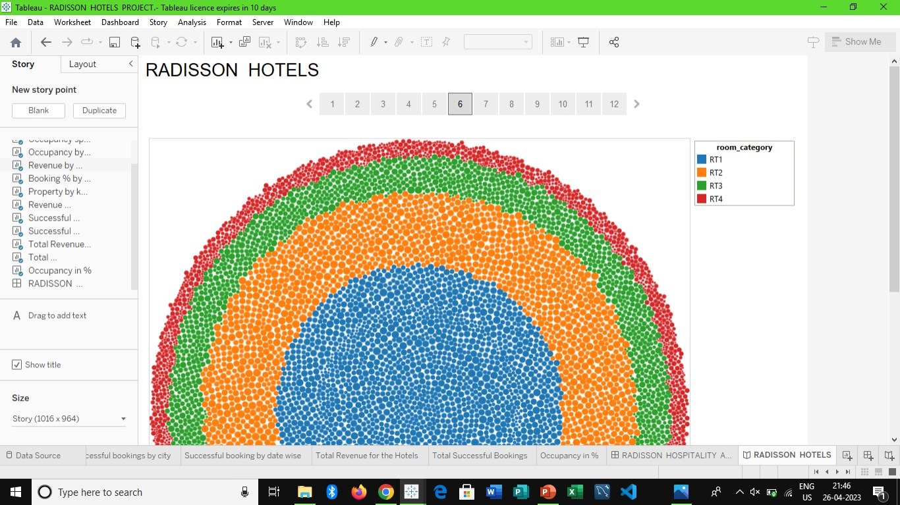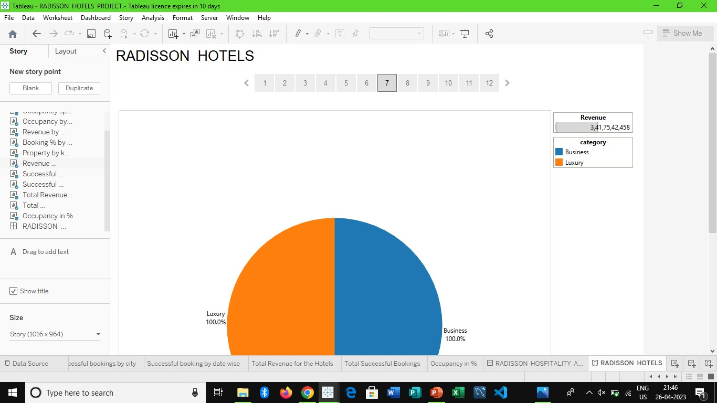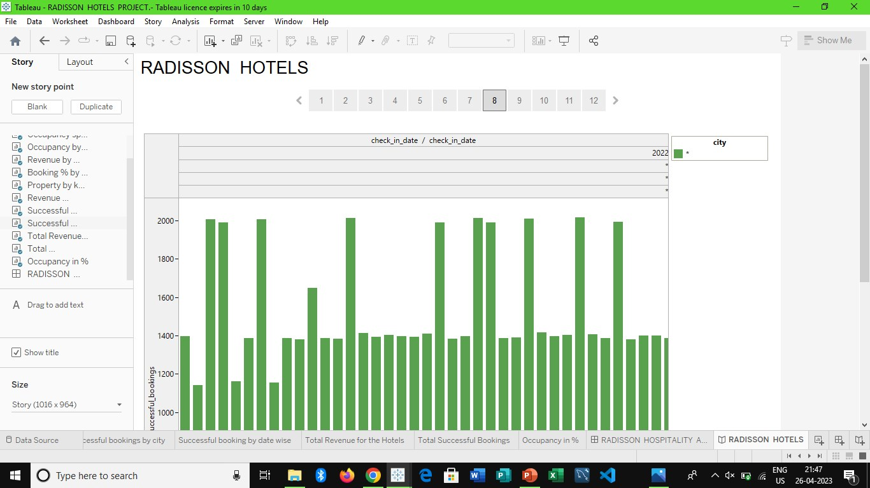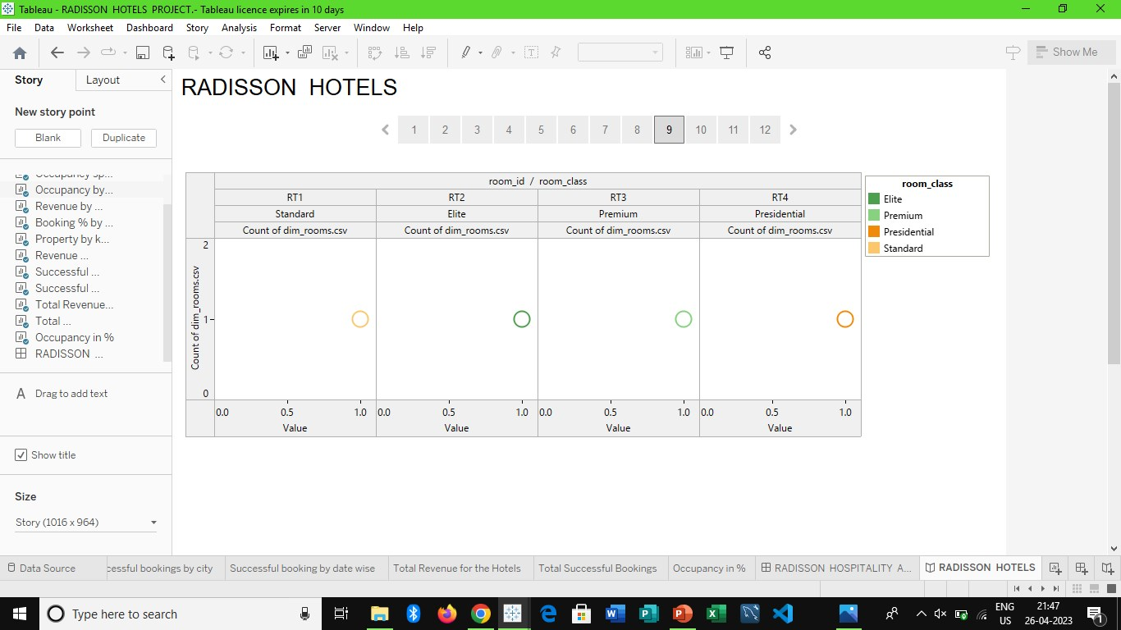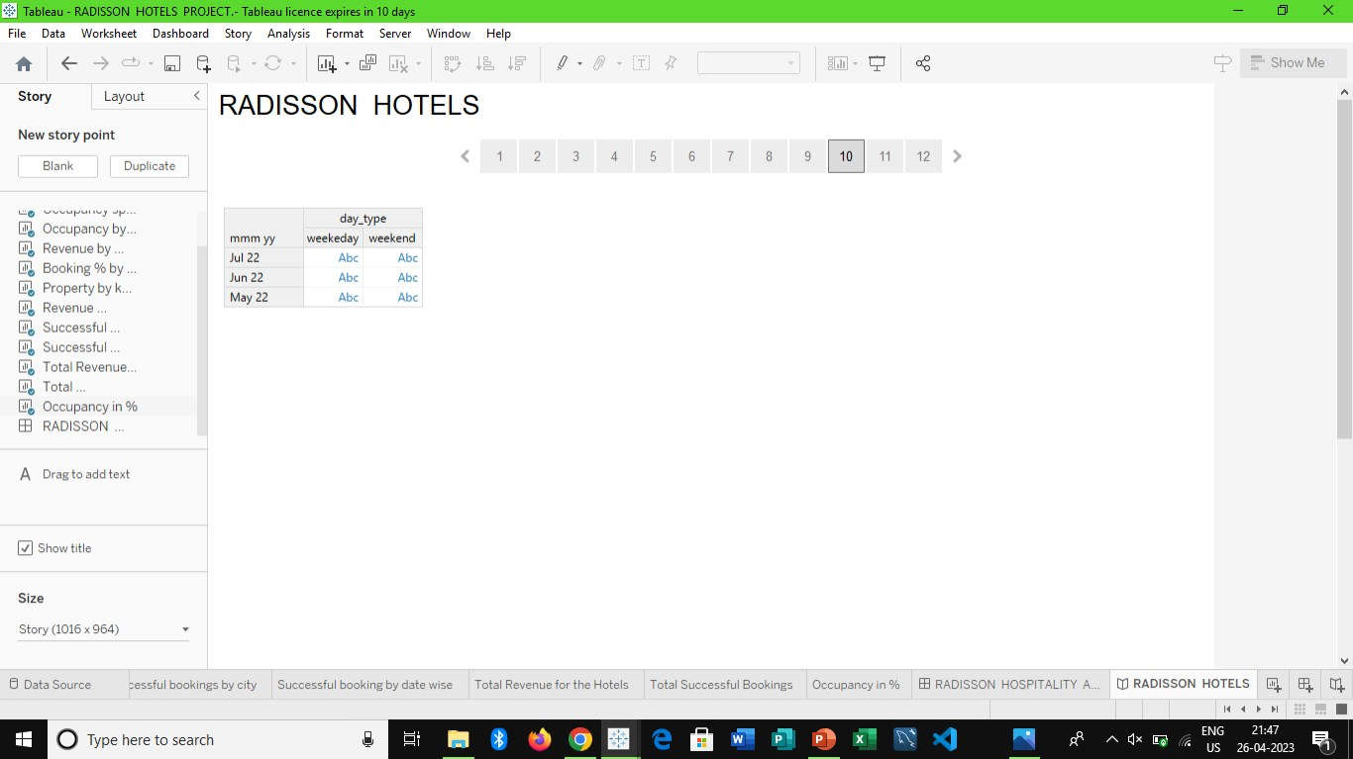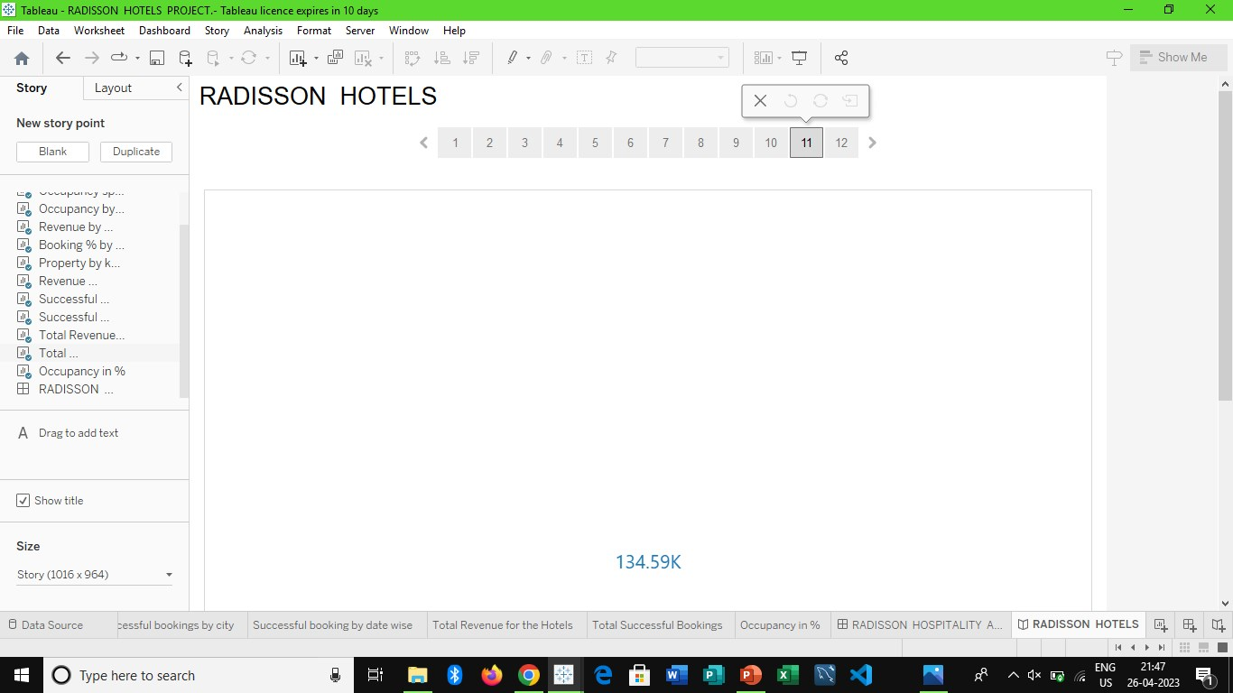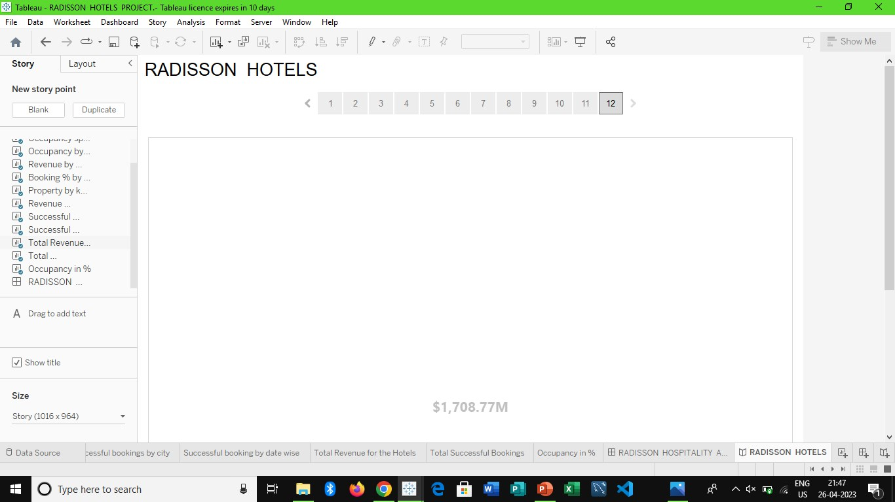

***4. USES:***

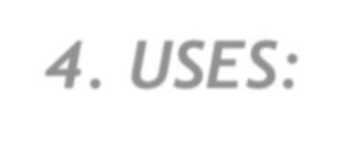

1. Revenue management service.

2. Overall Guest experience. 3. Effective Marketing.

4. Competitor analysis. 5. Better services.

***5. PURPOSES:***



* Strive to be the first choice in the mind of guests, owners and talent.

*Radisson Hotels is an international hotel chain headquartered in the United States.

*We are present in over 95 countries with nine distinctive brands. Together with our partners, we continue to develop new hotels and generate synergies to go much further.

***6. ADVANTAGES:***



* More security

* No contract, No bureaucracy * More flexibility

* Privileged location * Goodbye tickets

***7. DISADVANTAGES:***



* Slow and Always

* Forced minimalism * No laundry

* No kitchen

* No fixed address * Hotel stuff

***Conclusion:***

As the conclusion, the hospitality industry provides the good service for their customer with their variety service.

At the heart of Radisson hotel group is our brand promise,

Every Moment Matters.

Appendix:

Source code:

<!DOCTYPE html>

<html lang="en">

<head>

  <meta charset="utf-8">

  <meta content="width=device-width, initial-scale=1.0" name="viewport">

  <title>Radisson Hotel</title>

  <meta content="" name="description">

  <meta content="" name="keywords">

  <!-- Favicons -->

  <link rel="stylesheet" href="{{url_for('static',filename='img/favicon.png')}}" rel="icon">

  <link rel="stylesheet" href="{{url_for('static',filename='img/apple-touch-icon.png')}}" rel="apple-touch-icon">

  <link rel="stylesheet" href="{{url_for('static',filename='vendor/animate.css/animate.min.css')}}">

  <!-- Google Fonts -->

  <link href="https://fonts.googleapis.com/css?family=Open+Sans:300,300i,400,400i,600,600i,700,700i|Playfair+Display:ital,wght@0,400;0,500;0,600;0,700;1,400;1,500;1,600;1,700|Poppins:300,300i,400,400i,500,500i,600,600i,700,700i" rel="stylesheet">

  <!-- Vendor CSS Files -->

  <link rel="stylesheet" href="{{url_for('static',filename='vendor/animate.css/animate.min.css')}}">

  <link rel="stylesheet" href="{{url_for('static',filename='vendor/aos/aos.css')}}">

  <link rel="stylesheet" href="{{url_for('static',filename='vendor/bootstrap/css/bootstrap.min.css')}}">

  <link rel="stylesheet" href="{{url_for('static',filename='vendor/bootstrap-icons/bootstrap-icons.css')}}">

  <link rel="stylesheet" href="{{url_for('static',filename='vendor/boxicons/css/boxicons.min.css')}}">

  <link rel="stylesheet" href="{{url_for('static',filename='vendor/glightbox/css/glightbox.min.css')}}">

  <link rel="stylesheet" href="{{url_for('static',filename='vendor/swiper/swiper-bundle.min.css')}}">

  <!-- Template Main CSS File -->

  <link rel="stylesheet" href="{{url_for('static',filename='css/style.css')}}">

  <!-- =======================================================

  * Template Name: Restaurantly - v3.9.1

  * Template URL: https://bootstrapmade.com/restaurantly-restaurant-template/

  * Author: BootstrapMade.com

  * License: https://bootstrapmade.com/license/

  ======================================================== -->

</head>

<body>

  <!-- ======= Top Bar ======= -->

  <div id="topbar" class="d-flex align-items-center fixed-top">

    <div class="container d-flex justify-content-center justify-content-md-between">

      <div class="contact-info d-flex align-items-center">

        <i class="bi bi-phone d-flex align-items-center"><span>+91 9589 55488 55</span></i>

        <i class="bi bi-clock d-flex align-items-center ms-4"><span> Mon-Sat: 10:00AM - 11:00PM</span></i>

      </div>

    </div>

  </div>

  <!-- ======= Header ======= -->

  <header id="header" class="fixed-top d-flex align-items-cente">

    <div class="container-fluid container-xl d-flex align-items-center justify-content-lg-between">

      <h1 class="logo me-auto me-lg-0"><a href="{{ url_for('index') }}">Radisson Hotel</a></h1>

      <!-- Uncomment below if you prefer to use an image logo -->

      <!-- <a href="index.html" class="logo me-auto me-lg-0"><img src="assets/img/logo.png" alt="" class="img-fluid"></a>-->

      <nav id="navbar" class="navbar order-last order-lg-0">

        <ul>

          <li><a class="nav-link scrollto active" href="#hero">Home</a></li>

          <li><a class="nav-link scrollto" href="#about">About</a></li>

          <li><a class="nav-link scrollto" href="#events">Events</a></li>

          <li><a class="nav-link scrollto" href="#chefs">Dashboard & Story</a></li>

          <li><a class="nav-link scrollto" href="#gallery">Gallery</a></li>

          <li><a class="nav-link scrollto" href="#contact">Contact</a></li>

        </ul>

        <i class="bi bi-list mobile-nav-toggle"></i>

      </nav><!-- .navbar -->

    </div>

  </header><!-- End Header -->

  <!-- ======= Hero Section ======= -->

  <section id="hero" class="d-flex align-items-center">

    <div class="container position-relative text-center text-lg-start" data-aos="zoom-in" data-aos-delay="100">

      <div class="row">

        <div class="col-lg-8">

          <h1>Welcome to <span>Radisson Hotel</span></h1>

          <h2>Radisson Hotels is an international hotel chain headquartered in the United States. A division of the Radisson Hotel Group, it operates the brands Radisson Blu, Radisson RED, Radisson Collection, Country Inn & Suites, and Park Inn by Radisson, among others.</h2>

        </div>

        <div class="col-lg-4 d-flex align-items-center justify-content-center position-relative" data-aos="zoom-in" data-aos-delay="200">

          <a href="https://www.youtube.com/watch?v=u6BOC7CDUTQ" class="glightbox play-btn"></a>

        </div>

      </div>

    </div>

  </section><!-- End Hero -->

  <main id="main">

    <!-- ======= About Section ======= -->

    <section id="about" class="about">

      <div class="container" data-aos="fade-up">

        <div class="row">

          <div class="col-lg-6 order-1 order-lg-2" data-aos="zoom-in" data-aos-delay="100">

            <div class="about-img">

               <img src="static/img/about.jpg" alt="">

            </div>

          </div>

          <div class="col-lg-6 pt-4 pt-lg-0 order-2 order-lg-1 content">

            <h3>Radisson Hotel Analysis</h3>

            <p class="fst-italic">

              Radisson owns multiple five-star hotels across India. They have been in the hospitality industry for the past 100 years. Due to strategic moves from other competitors and ineffective decision-making in management, Radisson are losing its market share and revenue in the luxury/business hotels category. As a strategic move, the managing director of Radisson wanted to incorporate Business and Data Intelligence in order to regain their market share and revenue.

            <p>

            </p>

          </div>

        </div>

      </div>

    </section><!-- End About Section -->

    <!-- ======= Events Section ======= -->

    <section id="events" class="events">

      <div class="container" data-aos="fade-up">

        <div class="section-title">

          <h2>Events</h2>

          <p>Organize Your Events in our Radisson Hotel</p>

        </div>

        <div class="events-slider swiper" data-aos="fade-up" data-aos-delay="100">

          <div class="swiper-wrapper">

            <div class="swiper-slide">

              <div class="row event-item">

                <div class="col-lg-6">

                  <img src="static/img/event-birthday.jpg" class="img-fluid" alt="">

                </div>

                <div class="col-lg-6 pt-4 pt-lg-0 content">

                  <h3>Birthday Parties</h3>

                  <div class="price">

                    <p><span>$189</span></p>

                  </div>

                  <p class="fst-italic">

                  </p>

                </div>

              </div>

            </div><!-- End testimonial item -->

            <div class="swiper-slide">

              <div class="row event-item">

                <div class="col-lg-6">

                  <img src="static/img/event-private.jpg" class="img-fluid" alt="">

                </div>

                <div class="col-lg-6 pt-4 pt-lg-0 content">

                  <h3>Private Parties</h3>

                  <div class="price">

                    <p><span>$290</span></p>

                  </div>

                  <p class="fst-italic">

                  </p>

                </div>

              </div>

            </div><!-- End testimonial item -->

            <div class="swiper-slide">

              <div class="row event-item">

                <div class="col-lg-6">

                  <img src="static/img/event-custom.jpg" class="img-fluid" alt="">

                </div>

                <div class="col-lg-6 pt-4 pt-lg-0 content">

                  <h3>Custom Parties</h3>

                  <div class="price">

                    <p><span>$99</span></p>

                  </div>

                </div>

              </div>

            </div><!-- End testimonial item -->

          </div>

          <div class="swiper-pagination"></div>

        </div>

      </div>

    </section><!-- End Events Section -->

    <!-- ======= Gallery Section ======= -->

    <section id="gallery" class="gallery">

      <div class="container" data-aos="fade-up">

        <div class="section-title">

          <h2>Gallery</h2>

          <p>Some photos from Our Restaurant</p>

        </div>

      </div>

      <div class="container-fluid" data-aos="fade-up" data-aos-delay="100">

        <div class="row g-0">

          <div class="col-lg-3 col-md-4">

            <div class="gallery-item">

              <a href="static/img/gallery/gallery-1.jpg" class="gallery-lightbox" data-gall="gallery-item">

                <img src="static/img/gallery/gallery-1.jpg" alt="" class="img-fluid">

              </a>

            </div>

          </div>

          <div class="col-lg-3 col-md-4">

            <div class="gallery-item">

              <a href="static/img/gallery/gallery-2.jpg" class="gallery-lightbox" data-gall="gallery-item">

                <img src="static/img/gallery/gallery-2.jpg" alt="" class="img-fluid">

              </a>

            </div>

          </div>

          <div class="col-lg-3 col-md-4">

            <div class="gallery-item">

              <a href="static/img/gallery/gallery-3.jpg" class="gallery-lightbox" data-gall="gallery-item">

                <img src="static/img/gallery/gallery-3.jpg" alt="" class="img-fluid">

              </a>

            </div>

          </div>

          <div class="col-lg-3 col-md-4">

            <div class="gallery-item">

              <a href="static/img/gallery/gallery-4.jpg" class="gallery-lightbox" data-gall="gallery-item">

                <img src="static/img/gallery/gallery-4.jpg" alt="" class="img-fluid">

              </a>

            </div>

          </div>

          <div class="col-lg-3 col-md-4">

            <div class="gallery-item">

              <a href="static/img/gallery/gallery-5.jpg" class="gallery-lightbox" data-gall="gallery-item">

                <img src="static/img/gallery/gallery-5.jpg" alt="" class="img-fluid">

              </a>

            </div>

          </div>

          <div class="col-lg-3 col-md-4">

            <div class="gallery-item">

              <a href="static/img/gallery/gallery-6.jpg" class="gallery-lightbox" data-gall="gallery-item">

                <img src="static/img/gallery/gallery-6.jpg" alt="" class="img-fluid">

              </a>

            </div>

          </div>

          <div class="col-lg-3 col-md-4">

            <div class="gallery-item">

              <a href="static/img/gallery/gallery-7.jpg" class="gallery-lightbox" data-gall="gallery-item">

                <img src="static/img/gallery/gallery-7.jpg" alt="" class="img-fluid">

              </a>

            </div>

          </div>

          <div class="col-lg-3 col-md-4">

            <div class="gallery-item">

              <a href="static/img/gallery/gallery-8.jpg" class="gallery-lightbox" data-gall="gallery-item">

                <img src="static/img/gallery/gallery-8.jpg" alt="" class="img-fluid">

              </a>

            </div>

          </div>

        </div>

      </div>

    </section><!-- End Gallery Section -->

    <!-- ======= Chefs Section ======= -->

    <section id="chefs" class="chefs">

      <div class="container" data-aos="fade-up">

        <div class="section-title">

          <center><p>Analysis Dashboard</p></center>

         47;RADISSONHOSPITALITYANALYSIS&#47;1.png' /> <param name='animate_transition' value='yes' /><param name='display_st<div class='tableauPlaceholder' id='viz1682560389049' style='position: relative'><noscript><a href='#'><img alt='&lt;RADISSON  HOSPITALY  ANALYSIS&gt; ' src='https:&#47;&#47;public.tableau.com&#47;static&#47;images&#47;RA&#47;RADISSONHOTELSPROJECT&#47;RADISSONHOSPITALITYANALYSIS&#47;1_rss.png' style='border: none' /></a></noscript><object class='tableauViz'  style='display:none;'><param name='host_url' value='https%3A%2F%2Fpublic.tableau.com%2F' /> <param name='embed_code_version' value='3' /> <param name='site_root' value='' /><param name='name' value='RADISSONHOTELSPROJECT&#47;RADISSONHOSPITALITYANALYSIS' /><param name='tabs' value='no' /><param name='toolbar' value='yes' /><param name='static_image' value='https:&#47;&#47;public.tableau.com&#47;static&#47;images&#47;RA&#47;RADISSONHOTELSPROJECT&#atic_image' value='yes' /><param name='display_spinner' value='yes' /><param name='display_overlay' value='yes' /><param name='display_count' value='yes' /><param name='language' value='en-US' /><param name='filter' value='publish=yes' /></object></div>                <script type='text/javascript'>                    var divElement = document.getElementById('viz1682560389049');                    var vizElement = divElement.getElementsByTagName('object')[0];                    if ( divElement.offsetWidth > 800 ) { vizElement.style.width='1320px';vizElement.style.height='4096px';} else if ( divElement.offsetWidth > 500 ) { vizElement.style.width='1320px';vizElement.style.height='4096px';} else { vizElement.style.width='100%';vizElement.style.height='4177px';}                     var scriptElement = document.createElement('script');                    scriptElement.src = 'https://public.tableau.com/javascripts/api/viz_v1.js';                    vizElement.parentNode.insertBefore(scriptElement, vizElement);                </script>

          <center><p>Analysis Story</p></center>

        </div>

        <div class="row">

         <div class='tableauPlaceholder' id='viz1682560603091' style='position: relative'><noscript><a href='#'><img alt='RADISSON  HOTELS ' src='https:&#47;&#47;public.tableau.com&#47;static&#47;images&#47;RA&#47;RADISSONHOTELSPROJECT&#47;RADISSONHOTELS&#47;1_rss.png' style='border: none' /></a></noscript><object class='tableauViz'  style='display:none;'><param name='host_url' value='https%3A%2F%2Fpublic.tableau.com%2F' /> <param name='embed_code_version' value='3' /> <param name='path' value='views&#47;RADISSONHOTELSPROJECT&#47;RADISSONHOTELS?:language=en-US&amp;:embed=true&amp;publish=yes' /> <param name='toolbar' value='yes' /><param name='static_image' value='https:&#47;&#47;public.tableau.com&#47;static&#47;images&#47;RA&#47;RADISSONHOTELSPROJECT&#47;RADISSONHOTELS&#47;1.png' /> <param name='animate_transition' value='yes' /><param name='display_static_image' value='yes' /><param name='display_spinner' value='yes' /><param name='display_overlay' value='yes' /><param name='display_count' value='yes' /><param name='language' value='en-US' /><param name='filter' value='publish=yes' /></object></div>                <script type='text/javascript'>                    var divElement = document.getElementById('viz1682560603091');                    var vizElement = divElement.getElementsByTagName('object')[0];                    vizElement.style.width='1016px';vizElement.style.height='991px';                    var scriptElement = document.createElement('script');                    scriptElement.src = 'https://public.tableau.com/javascripts/api/viz_v1.js';                    vizElement.parentNode.insertBefore(scriptElement, vizElement);                </script>

        </div>

      </div>

    </section><!-- End Chefs Section -->

    <!-- ======= Contact Section ======= -->

    <section id="contact" class="contact">

      <div class="container" data-aos="fade-up">

        <div class="section-title">

          <h2>Contact</h2>

          <p>Contact Us</p>

        </div>

      </div>

      <div class="container" data-aos="fade-up">

        <div class="row mt-5">

          <div class="col-lg-4">

            <div class="info">

              <div class="address">

                <i class="bi bi-geo-alt"></i>

                <h4>Location:</h4>

                <p>Radisson Hotel Bhopal,Gulmohar Colony, Bhopal, Madhya Pradesh 462039</p>

              </div>

              <div class="open-hours">

                <i class="bi bi-clock"></i>

                <h4>Open Hours:</h4>

                <p>

                  Monday-Saturday:<br>

                  10:00 AM - 11:00 PM

                </p>

              </div>

              <div class="email">

                <i class="bi bi-envelope"></i>

                <h4>Email:</h4>

                <p>info@radisson.com</p>

              </div>

              <div class="phone">

                <i class="bi bi-phone"></i>

                <h4>Call:</h4>

                <p>+91 9589 55488 55</p>

              </div>

            </div>

          </div>

          <div class="col-lg-8 mt-5 mt-lg-0">

            <div class="mapouter"><div class="gmap_canvas"><iframe class="gmap_iframe" frameborder="0" scrolling="no" marginheight="0" marginwidth="0" src="https://maps.google.com/maps?width=600&amp;height=400&amp;hl=en&amp;q=radisson bhopal&amp;t=&amp;z=14&amp;ie=UTF8&amp;iwloc=B&amp;output=embed"></iframe><a href="https://mcpedls.com/">minecraft download</a></div><style>.mapouter{position:relative;text-align:right;width:600px;height:400px;}.gmap_canvas {overflow:hidden;background:none!important;width:600px;height:400px;}.gmap_iframe {width:600px!important;height:400px!important;}</style></div>

          </div>

        </div>

      </div>

    </section><!-- End Contact Section -->

  </main><!-- End #main -->

  <!-- ======= Footer ======= -->

  <footer id="footer">

    <div class="footer-top">

      <div class="container">

        <div class="row">

          <div class="col-lg-3 col-md-6">

            <div class="footer-info">

              <h3>Radisson Hotel</h3>

              <p>

                Radisson Hotel Bhopal,Gulmohar Colony <br>

                Bhopal, Madhya Pradesh 462039<br><br>

                <strong>Phone:</strong> +91 9589 55488 55<br>

                <strong>Email:</strong> info@radisson.com<br>

              </p>

              <div class="social-links mt-3">

                <a href="#" class="twitter"><i class="bx bxl-twitter"></i></a>

                <a href="#" class="facebook"><i class="bx bxl-facebook"></i></a>

                <a href="#" class="instagram"><i class="bx bxl-instagram"></i></a>

                <a href="#" class="google-plus"><i class="bx bxl-skype"></i></a>

                <a href="#" class="linkedin"><i class="bx bxl-linkedin"></i></a>

              </div>

            </div>

          </div>

          <div class="col-lg-2 col-md-6 footer-links">

            <h4>Useful Links</h4>

            <ul>

              <li><i class="bx bx-chevron-right"></i> <a href="#">Home</a></li>

              <li><i class="bx bx-chevron-right"></i> <a href="#">About us</a></li>

              <li><i class="bx bx-chevron-right"></i> <a href="#">Services</a></li>

            </ul>

          </div>

          </div>

        </div>

      </div>

    </div>

    <div class="container">

      <div class="copyright">

        &copy; Copyright <strong><span>Radisson Hotel</span></strong>. All Rights Reserved

      </div>

      <div class="credits">

        <!-- All the links in the footer should remain intact. -->

        <!-- You can delete the links only if you purchased the pro version. -->

        <!-- Licensing information: https://bootstrapmade.com/license/ -->

        <!-- Purchase the pro version with working PHP/AJAX contact form: https://bootstrapmade.com/restaurantly-restaurant-template/ -->

        Designed by <a href="https://bootstrapmade.com/">SmartBridge</a>

      </div>

    </div>

  </footer><!-- End Footer -->

  <div id="preloader"></div>

  <a href="#" class="back-to-top d-flex align-items-center justify-content-center"><i class="bi bi-arrow-up-short"></i></a>

  <!-- Vendor JS Files -->

  <script src="{{ url_for('static', filename='vendor/aos/aos.js') }}"></script>

  <script src="{{ url_for('static', filename='vendor/bootstrap/js/bootstrap.bundle.min.js') }}"></script>

  <script src="{{ url_for('static', filename='vendor/glightbox/js/glightbox.min.js') }}"></script>

  <script src="{{ url_for('static', filename='vendor/isotope-layout/isotope.pkgd.min.js') }}"></script>

  <script src="{{ url_for('static', filename='vendor/swiper/swiper-bundle.min.js') }}"></script>

  <script src="{{ url_for('static', filename='vendor/php-email-form/validate.js') }}"></script>

  <!-- Template Main JS File -->

  <script src="{{ url_for('static', filename='js/main.js') }}"></script>

</body>

</html>